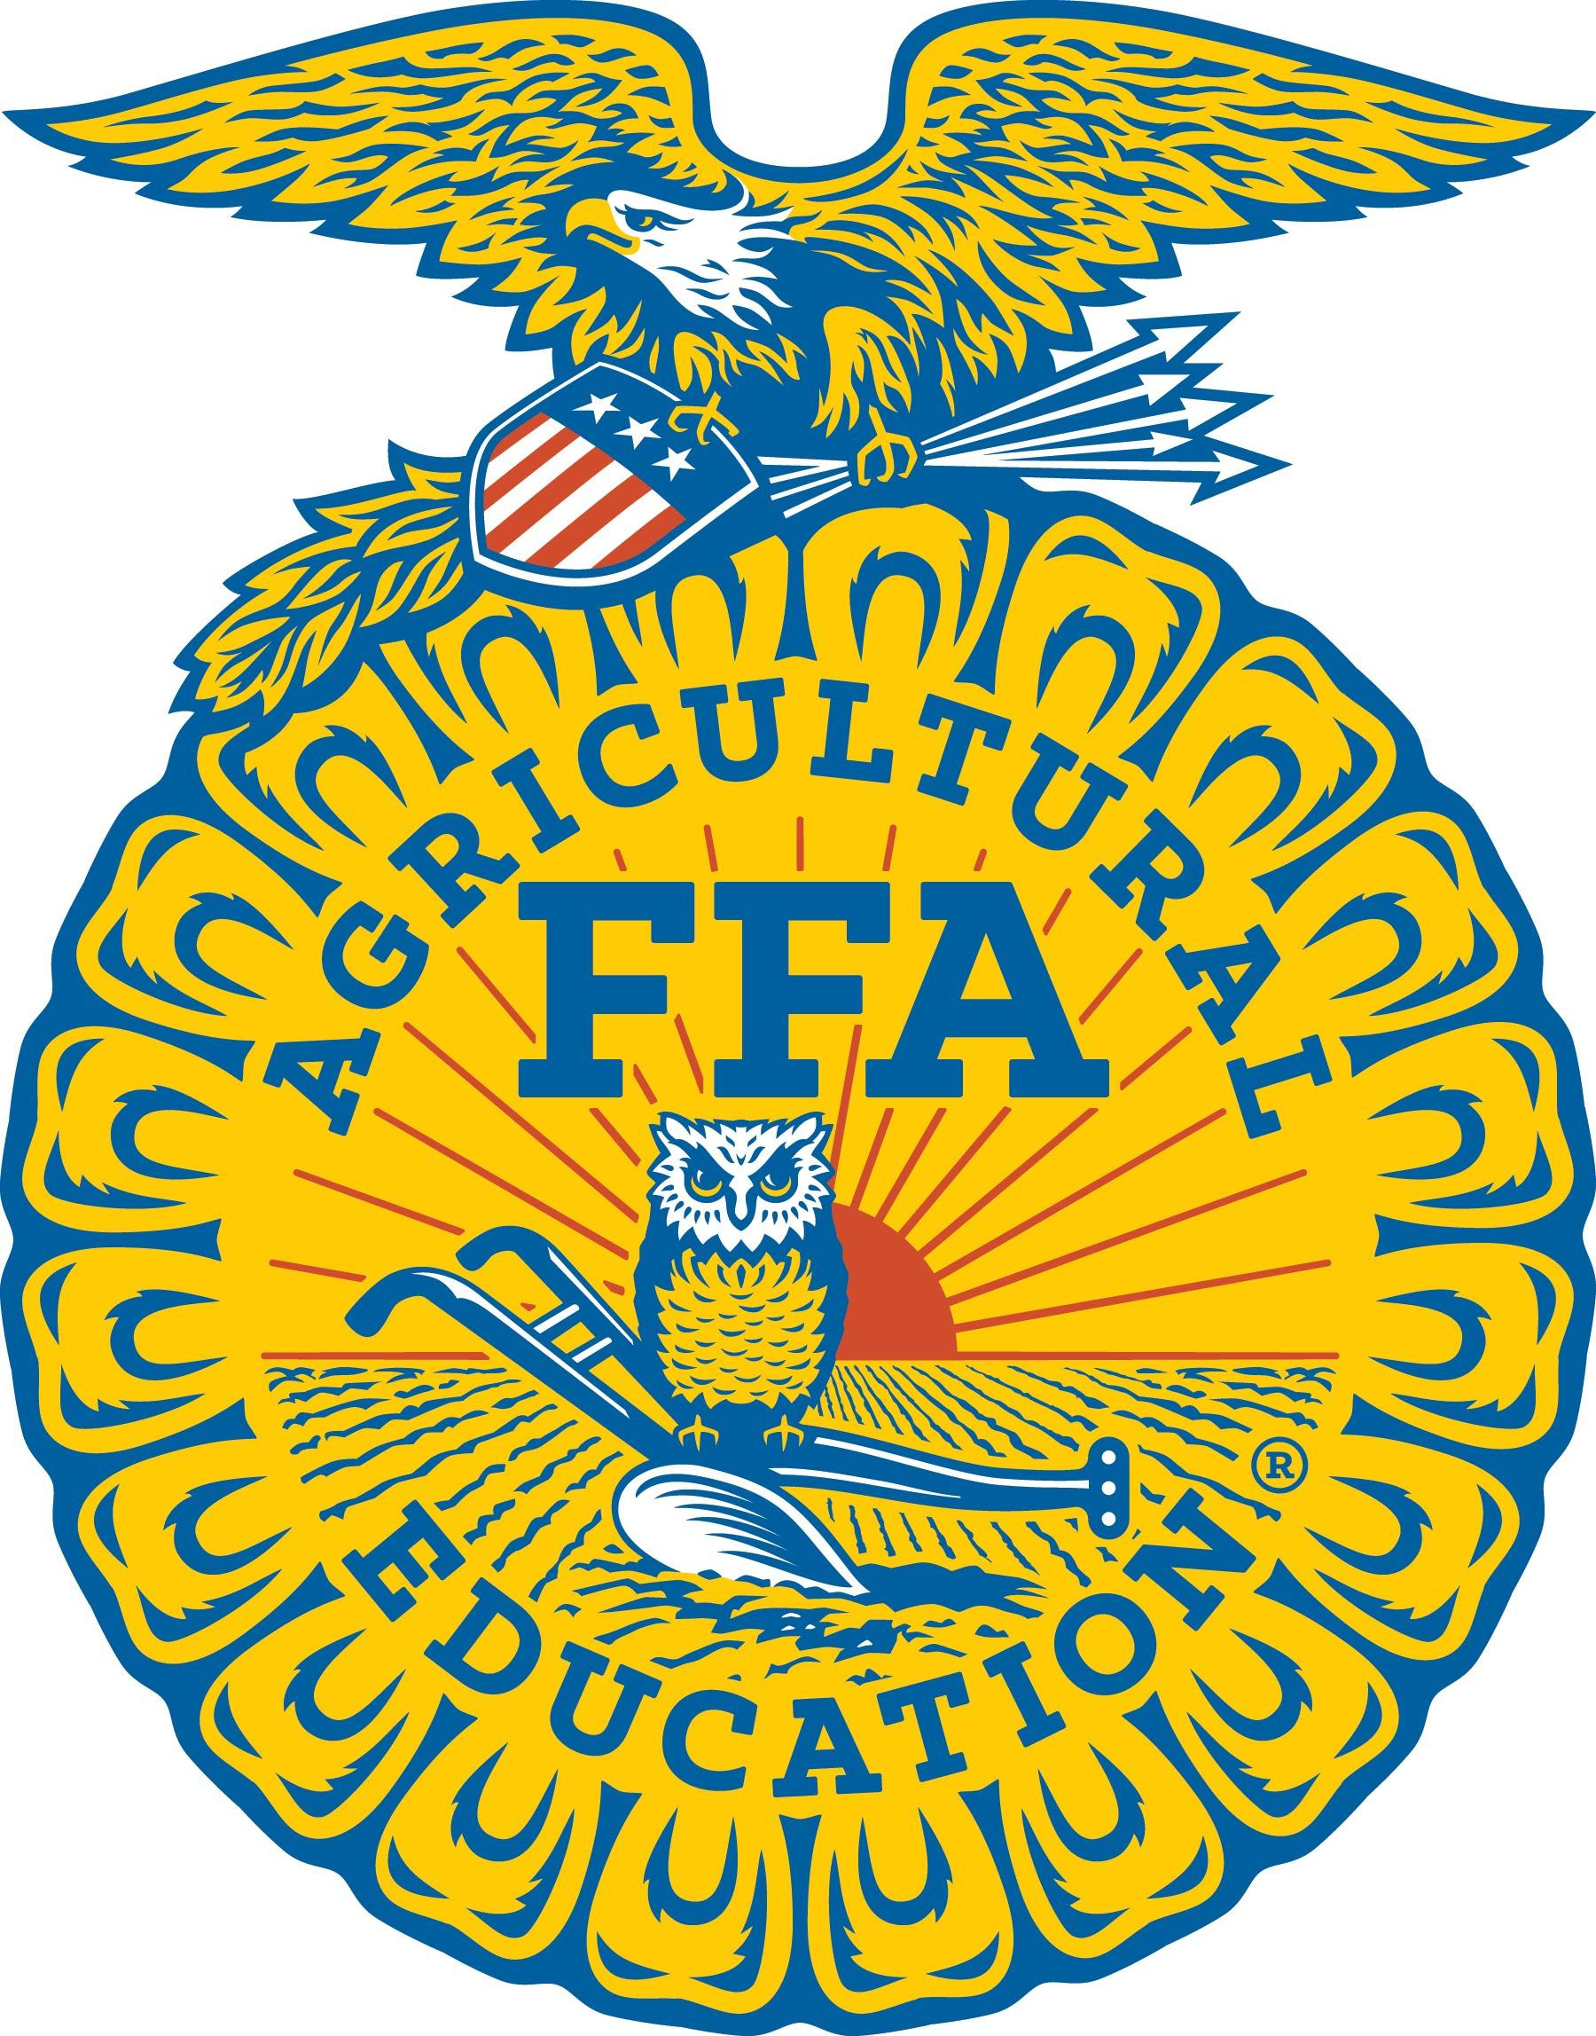
NEWS RELEASE FROM:
Gerri Ann Eide
SD FFA Foundation
gerri@sdffafoundation.org

2019 SOUTH DAKOTA STATE FAIR FFA RESULTS

Members of the South Dakota FFA participated in a wide range of educational activities during the 2019 South Dakota State Fair held August 29-September 2nd in Huron. At the State Fair, there were a record 358 FFA members who exhibited 1121 exhibits. Results were as follows:

CHAPTER SWEEPSTAKES
1st – McCook Central

CHAPTER EXHIBITS:

1st place – Beresford; 2nd place – Arlington; 3rd place – Parker
Sponsored by Valley Queen Cheese Factory, Milbank.

TOP AG EXHIBITS CHAPTER:
1st place – McCook Central
Sponsored by Valley Queen Cheese Factory, Milbank.

TOP AGRISCIENCE EXHIBITS:
1st place - Hadley Stiefvater, McCook
2nd place - Teagan Mason, Doland
3rd place - Hunter Eide, Gettysburg
Sponsored by Jakober Limousin, Aberdeen.

Photos available at: https://drive.google.com/drive/folders/1lFltUoGpa7yXXRzvyPM7NDB_Odq9Ibp3?usp=sharing

BEEF SHOW
Champion Market Steer – Bryce Beitelspacher, Bowdle
Reserve Champion Market Steer – Ryley Hellmann, Bon Homme
Champion Market Heifer – McKenzye Gunderson, Harrisburg
Reserve Champion Market Heifer – Tessa Pederson, Garretson
Market Beef Showmanship – 1st: Savannah Vogel, Winner; 2nd: Kylie Grace Harriman, Menno; 3^{rd:} Payton Beare, Highmore; 4th: Mitchell VanderWal, Northwestern Area; 5th: Madison Evie, Selby
Champion English Breeding Heifer – Jady LeDoux, Highmore
Reserve Champion English Breeding Heifer – Sawyer Styles, Northwestern Area
Champion Exotic Breeding Heifer – Kenidey Effling, Highmore
Reserve Champion Exotic Breeding Heifer –Kenzy Beare, Estelline
Overall Grand Champion Breeding Heifer - Jady LeDoux, Highmore
Overall Reserve Champion Breeding Heifer - Kenidey Effling, Highmore
Breeding Beef Showmanship – 1st: Logan Zemlicka, Wolsey-Wessington; 2nd: Sawyer Styles, Northwestern Area; 3rd: Tate Johnson, Beresford; 4th: Sawyer Naasz, Platte/Geddes; 5th: Drew Pederson, Garretson
Breeding and Market Beef Showmanship sponsored by Jakober Limousin, Aberdeen

SWINE SHOW
Champion Market Gilt – Melanie Calmus, Howard
Reserve Champion Market Gilt – Cash Lehrman, Bridgewater-Emery
Market Gilt Showmanship- 1st: Jeffrey Paulson, Clark; 2nd: Ashton Ross, Lennox-Sundstrom; 3rd: Abby Blagg, McCook Central; 4th: Brian Feldhaus, Howard; 5th: Ty Van Hull, Viborg-Hurley
Champion Market Barrow – Cash Lehrman, Bridgewater-Emery
Reserve Market Barrow – Makayla Nelson, Arlington
Market Barrow Showmanship – 1st: Grace DiGiovanni, McCook Central; 2nd Delanie Tangen, Sioux Valley; 3rd: Jackson Nordlund, McCook Central; 4th: Preston Mattheis, Parkston; 5th: Rylee Schultz, Bridgewater-Emery
Swine Showmanship sponsored by Thompson Family, Harrisburg

SHEEP SHOW
Champion Breeding Ewe – Mary Nold, Rutland
Reserve Champion Breeding Ewe – Kasandra Knutson, Viborg-Hurley
Champion Ram - Camden Miller, Estelline
Reserve Champion Ram– Wesley Linke, Sanborn Central/Woonsocket
Breeding Sheep Showmanship – 1st : Riggen Zelinsky, Brookings; 2nd: Mary Nold, Rutland; 3rd: Logan Slack, Viborg-Hurley; 4th Raesa Zelinsky, Brookings; 5th: Emily Nold, Rutland
Champion Market Lamb – Ella Stiefvater, McCook Central
Reserve Champion Market Lamb – Brianna Larson, Brookings
Market Lamb Showmanship – 1st: Jessica Kott, Kimball; 2nd: Colton Michalek, Kimball FFA; 3rd: Raina Johnson, Harrisburg; 4th: Tessa Pederson, Garreston; 5th: Taya Chelmo, Kimball
Breeding and Market Sheep Showmanship sponsored by Knutson Suffolks, Centerville

GOAT SHOW
Champion Breeding Meat Goat – Lane Miller, Howard
Reserve Champion Breeding Meat Goat – Hanna Peterson, Howard
Breeding Meat Goat Showmanship – 1st: Colton Michalek, Kimball; 2nd: Drew Pederson, Garretson; 3rd: Kahli Gall, Freeman; 4th: Reid Leischner, Parkston; 5th: Parker Johnson, Tri-Valley
Champion Market Meat Goat – Riley Larson, Wessington Springs
Reserve Champion Market Meat Goat – Hanna Peterson, Howard
Market Meat Goat Showmanship – 1st: Ryder Michalek, Kimball; 2nd: Jared Stearns, Hot Springs; 3rd: Tessa Erdmann, Groton; 4th: Riley Larson, Wessington Springs; 4th: 5th: Travis Townsend, Groton
Breeding and Market Meat Goat Showmanship sponsored by Lazy J Bar Ranch, Mina

DAIRY GOAT SHOW
Overall Champion - Trevon Cross, Dell Rapids
Overall Reserve Champion - Trevon Cross, Dell Rapids
Champion Milking Doe – Trevon Cross, Dell Rapids
Reserve Champion Milking Doe – Trevon Cross, Dell Rapids
Champion Dairy Goat - Trevon Cross, Dell Rapids
Reserve Champion Dairy Goat - Bailey Schlotterbeck, Florence
Dairy Goat Showmanship- 1st: Trevor Cross, Dell Rapids; 2nd: Bailey Schlotterbeck, Florence; 3rd: Ashley Engel, Chamberlain; 4th: Swade Reis, Chamberlain 5th: Alana Howard, Miller
Dairy Goat Awards sponsored by Boldt Farms, Arlington

RABBIT SHOW
Grand Champion Rabbit – Trapper Miklos, Arlington
Reserve Champion Rabbit – Avery Miles, Doland
Grand & Reserve inkind awards sponsored by Mark & Staci Schloe
Rabbit Showmanship – 1st: Corissa Sweeter, Lennox-Sundstrom; 2nd: Taylor McMartin, West Central; 3rd: Avery Miles, Doland
Rabbit Showmanship sponsored by Woehl's Rabbits/Randy & Phyllis Woehl

DAIRY SHOW
Supreme Champion Female – Jordan Zoellner, Harrisburg
Champion Holstein Female – Jordan Zoellner, Harrisburg
Senior Champion Holstein – Jordan Zoellner, Harrisburg
Senior Reserve Champion Holstein – Bethany Rennich, Sioux Valley
Junior Champion Holstein Heifer – Natalie Haase, Parker
Junior Reserve Champion Holstein Heifer – Steven Paulson, Groton
Champion All Other Breed Female – Jordan Zoellner, Harrisburg
Senior Champion All Other Breed – Jordan Zoellner, Harrisburg
Senior Reserve Champion All Other Breed – Jordan Zoellner, Harrisburg
Junior Champion All Other Breed Heifer – Jordan Zoellner, Harrisburg
Junior Reserve Champion All Other Breed Heifer – Skyler Plucker, Lennox Sundstrom
Dairy Showmanship: 1st: Natalie Haase, Parker; 2nd: Bethany Rennich, Sioux Valley; 3rd: Jordan Zoellner, Harrisburg; 4th: Travis Sharp, Aberdeen Central; 5th: Elissa Oyen, Tri-Valley

Dairy Showmanship and Supreme Champion Dairy Female sponsored by Valley Queen Cheese Factory, Milbank.
Champion Dairy Cattle Handler travel scholarship sponsored by PostLane Dairy, Marv & Joy Post.

ROUND ROBIN SHOWMANSHIP
1st Place – Raesa Zelinkski – Brookings
2nd Place - Jessica Kott – Kimball
Round Robin Showmanship sponsored by Odden Cattle Company and Odden Trucking, Ree Heights.

FFA Livestock Show premiums sponsored through the SD FFA Foundation by Pulse Electric, LLC, Stengl Oils, and the SD Cattlemen’s Foundation; and through the SD State Fair by First National Bank, Wells Fargo, and Dakota Energy Cooperative.

